PUBLIC NOTICE
AUMSVILLE PLANNING COMMISSION MEETING
Aumsville Community Center
555 Main Street, Aumsville, OR
THURSDAY, November 10th, 2022
AGENDA
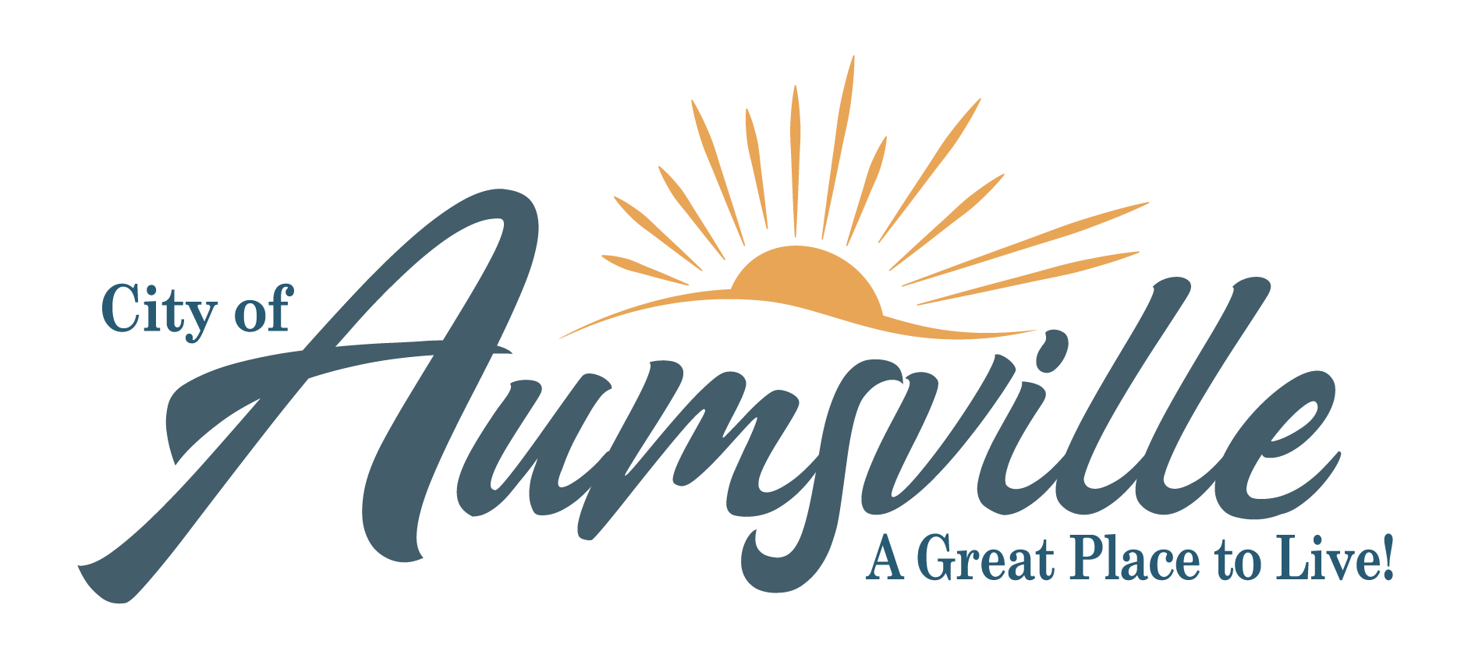
595 Main Street, Aumsville, OR 97325
Office: (503) 749-2030 FAX: (503) 749-1852
Email: rharding@aumsville.us
CALL TO ORDER: 6:00 pm

VISITORS: Visitors are welcome to attend in-person or via Zoom. For information about how to attend the meeting online, please email hbrewster@aumsville.us to request log in instructions.

APPROVAL OF MINUTES: September 15, 2022 APC Meeting Minutes

UNFINISHED BUSINESS: NONE

NEW BUSINESS: Public Hearing

PUBLIC HEARING: Review Proposed Development Code Revisions
1. Open Public Hearing
2. Declaration of Interests
3. Preliminary Matters
4. Opening Statement
5. Staff Report
6. Applicant Testimony
7. Proponent(s) Testimony*
8. Opponent(s) Testimony*
9. Governmental Agencies

10. General Testimony
11. Questions from the Public**
12. Questions from the Commission
13. Applicant Summary
14. Staff Summary
15. Close or Continue the Hearing
16. Deliberation
17. Decision

CORRESPONDENCE: NONE

OTHER BUSINESS: NONE

FUTURE AGENDA ITEMS: TBD

NEXT MEETING: TBD

ADJOURNMENT

The City of Aumsville does not and shall not; discriminate on the basis of race, color, religion (creed), gender, gender expression, age, national origin (ancestry), disability, marital status, sexual orientation, or military status, in any of its activities or operations.
Anyone wishing to speak on an agenda item should ask to be recognized by the Mayor or Chair at the beginning of that agenda item. The meeting location is accessible to persons with disabilities. A request for an interpreter for the hearing impaired, or for other accommodations for persons with disabilities must be made at least 48 hours prior to the meeting. Please call (503) 749-2030 and leave a message or Oregon Relay Service for TDD at (800) 735-2900.

